Autumn Offers
Dentastix Small/Medium/Large
RRP - £9.10
OFFER – £7.50

Autumn Offers
Felix Pouch
(12 x 100g)
RRP - £5.33
OFFER – £4.99
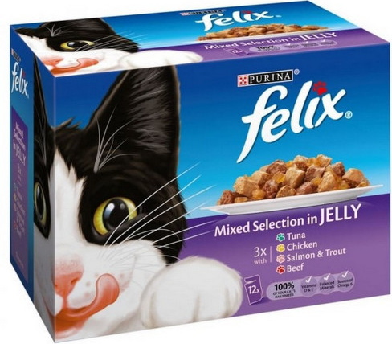

Autumn Offers
2KG Whiskas
RRP - £10.81
OFFER – £7.99
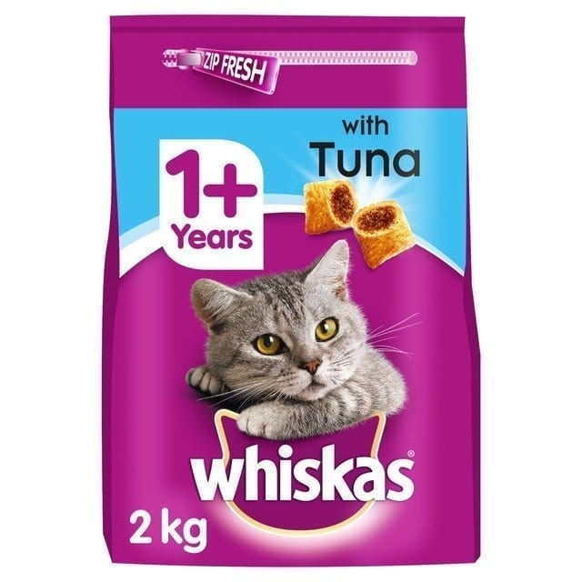

Autumn Offers
Whiskas Pouch
(12 x 85g)
RRP - £5.06
OFFER – £4.75
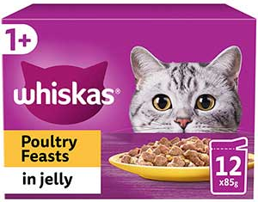

Autumn Offers
Felix Agail Pouch
(12 x 100g)
RRP - £6.48
OFFER – £5.75

Autumn Offers
1.5kg/2kg James Wellbeloved Dog
RRP - £12.50
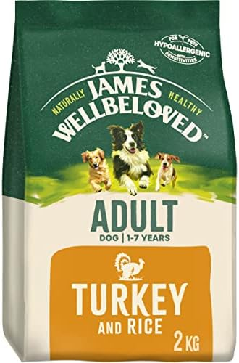
OFFER – £10.99

Autumn Offers
Gourmet Perle
(12 x 85g)
RRP - £7.22
OFFER – £6.50
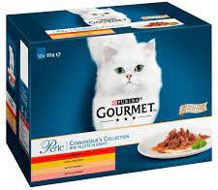

Autumn Offers
2kg Iams Cat
RRP - £12.50
OFFER – £10.50

